**Design & Technology**

**

**Materials and objects can be manipulated to resist and work with forces and stresses**

**Materials required for questions**

* Pencil
* Rubber
* Calculator

**Instructions**

* Use black ink or ball-point pen
* Try answer all questions
* Use the space provided to answer questions
* Calculators can be used if necessary
* For the multiple choice questions, circle your answer

**Advice**

* Marks for each question are in brackets
* Read each question fully
* Try to answer every question
* Don’t spend too much time on one question

**Good luck!**

**Q1.** What is the main force being exhibited during a tug of war?

**A** Compression

**B** Tension

**C** Bending

**Q2.** What is the main force being exhibited when someone sits on a stool?

**A** Compression

**B** Tension

**C** Bending

**Q3.** What is the main force being exhibited when someone cuts paper with scissors?

**A** Torsion

**B** Tension

**C** Shear

**Q4.** What is the man force being exhibited when someone crosses a wooden plank bridge

**A** Compression

**B** Torsion

**C** Bending

**Q5.** Describe what forces are acting on the bow and arrow in the image below before it is fired **(3 marks)**

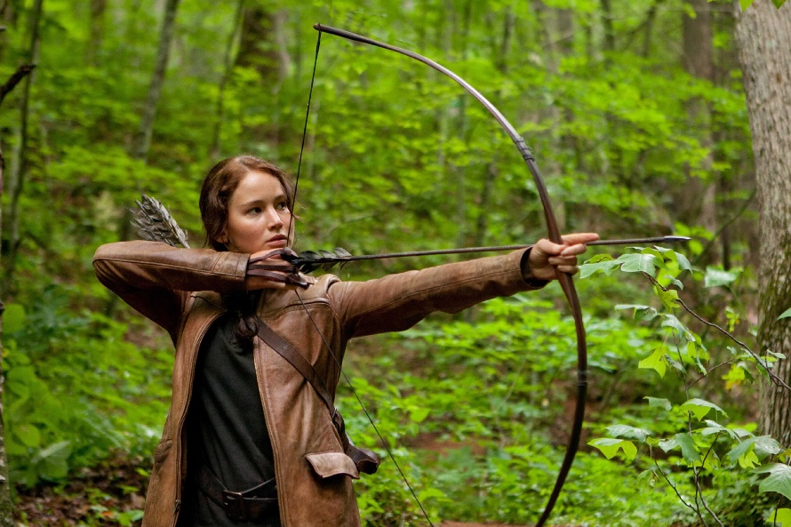

**Answers**

**Q1**. B

**Q2**. A

**Q3**. C

**Q4**. C

**Q5.**

* Tension
* Compression
* Bending